Design Report : Encore, IPD group 35

1. Introduction

The design is a step-down (buck) DC-DC converter that steps down an input voltage of 24V to a stable output voltage of 5V. The primary components include a switching MOSFET (IRFZ44N), a PWM controller based on a 555 timer, passive components (capacitors, inductor), and a Schottky diode for current rectification. The goal of the design is to provide efficient power conversion from 24V to 5V with minimal losses, suitable for powering low-voltage devices from a higher voltage source.

2. Schematic Overview

The circuit consists of two main sections:

PWM Generator using NE555 Timer:

A standard astable multivibrator setup creates a pulse-width modulation (PWM) signal. The 555 timer generates a square wave signal that controls the gate of the MOSFET. Resistors R1, R4, and R5, along with capacitor C1, set the frequency and duty cycle of the PWM signal.

Key Components:

NE555P Timer

R1 (27.3kΩ), R4 (10kΩ), R5 (2.7kΩ)

C1 (100nF)

D1 (1N4148) – Clamping diode for safe operation

PWM control signal output at pin 3

Buck Converter Circuit:

This is the power stage where the MOSFET IRFZ44N switches on and off, regulating the output voltage by controlling the duty cycle of the switching. The inductor L1 (100 µH) and capacitor Cout1 (300 µF) filter the output, ensuring low ripple voltage at the output.

Key Components:

MOSFET Q2 (IRFZ44N) – Switch controlled by the PWM signal

Diode D2 (Schottky B360) – Allows for freewheeling current when the MOSFET is off

L1 (100 µH), Cout1 (300 µF) – Filter out high-frequency switching noise and maintain a stable DC output

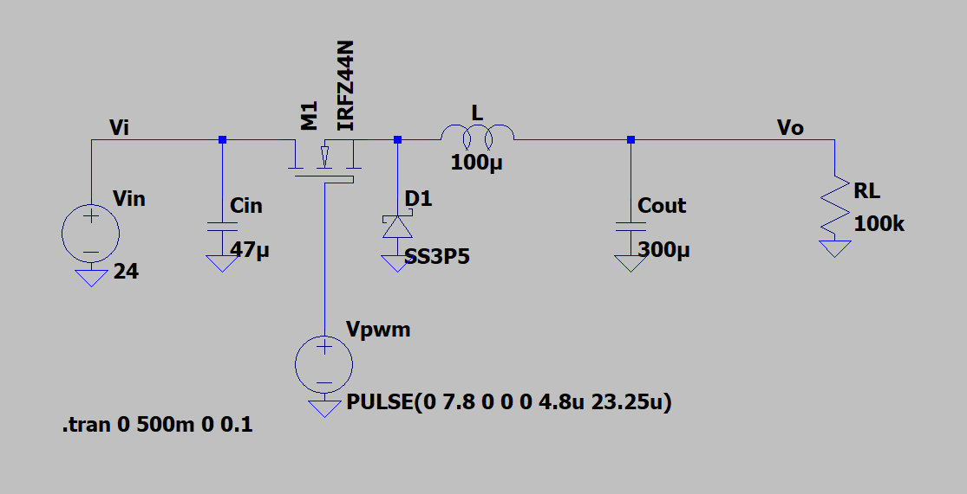

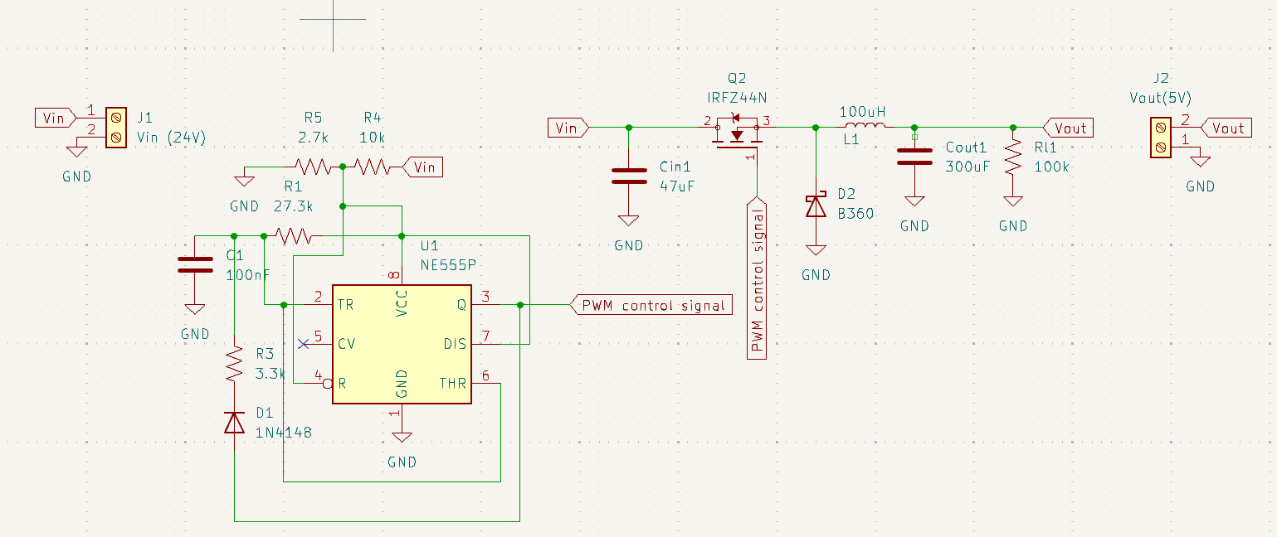

3. PCB Design

The PCB layout is compact and designed with minimal trace lengths to reduce parasitic inductances and improve efficiency. Key aspects of the PCB design:

Power Traces: Thicker traces are used for high-current paths (from input through the MOSFET, inductor, and diode to the output).

Grounding: A proper ground plane is provided to ensure stable operation and minimize noise.

Component Placement: The placement of the components follows a logical flow from input to output, with the NE555 timer near the gate of the MOSFET to ensure a clean PWM signal.

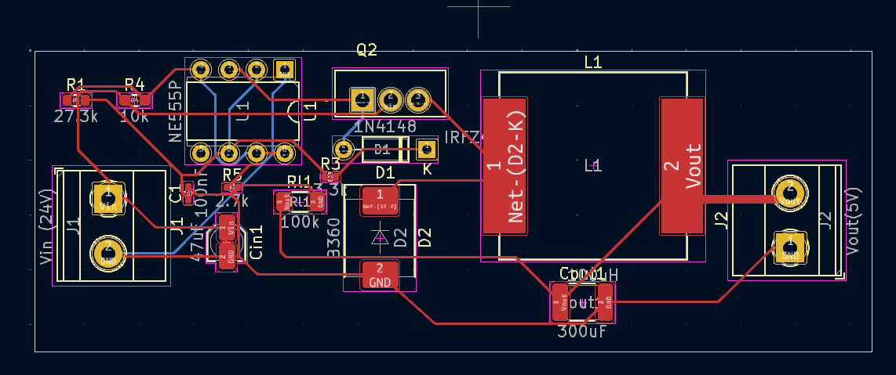

4. Component Description

IRFZ44N (Q2):

N-channel MOSFET capable of handling up to 49A and 55V, which ensures that the converter can handle high input currents with minimal conduction losses.

555 Timer (U1):

Provides the PWM control signal with the frequency and duty cycle determined by external resistors (R1, R4, R5) and capacitor C1.

Inductor (L1):

A 100 µH inductor that smoothens the current by storing energy during the on-time of the MOSFET and releasing it during the off-time.

Schottky Diode (D2, B360):

A low-forward voltage Schottky diode used for freewheeling current when the MOSFET is off, improving efficiency due to lower power losses.

Capacitors (Cin1 and Cout1):

Cin1 (47 µF) and Cout1 (300 µF) stabilize the input and output voltages by filtering out high-frequency noise.

5. Operation

The NE555 timer generates a PWM signal with a frequency determined by the values of R1, R4, R5, and C1. This PWM signal is fed into the gate of the MOSFET (Q2), controlling the switching of the MOSFET.

During the on-time of the MOSFET, current flows through the inductor (L1), storing energy in its magnetic field. During the off-time, the stored energy in the inductor maintains current flow through the diode (D2), ensuring continuous current to the load.

The output voltage is regulated by adjusting the duty cycle of the PWM signal. Higher duty cycles increase the output voltage, while lower duty cycles decrease it.

6. PWM Control Signal

The pulse width is modulated using the following values:

PULSE(0 7.8 0 0 0 4.8u 23.25u)

This defines a pulse with 7.8V amplitude, a 0-second initial delay, and a pulse width of 4.8 microseconds with a total period of 23.25 microseconds. This results in a switching frequency of approximately 43 kHz, which is typical for buck converters.

7. Performance Estimations

Input Voltage: 24V

Output Voltage: 5V

Load Resistance: 100kΩ

Switching Frequency: ~43 kHz

Duty Cycle: Estimated at ~20.7% (based on the ratio of output to input voltage,

𝑉𝑜𝑢𝑡/𝑉𝑖𝑛=𝐷(V out/V in=D)

Efficiency: Expected to be high due to the use of a Schottky diode, low on-resistance MOSFET, and minimized ripple due to proper filtering.

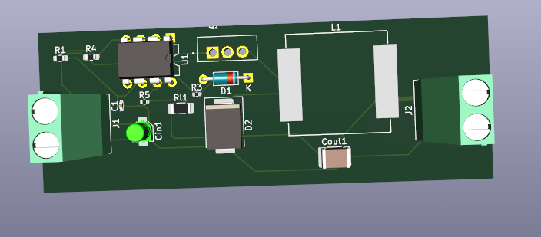

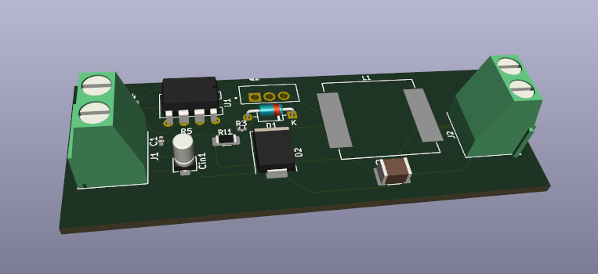

8. PCB Routing

Care was taken to minimize trace inductance and resistance, which could cause switching noise and reduce efficiency. Power and ground planes were used where applicable to ensure solid electrical performance.

9. Conclusion

This buck converter design efficiently steps down 24V to 5V, suitable for applications requiring regulated low-voltage DC power. The combination of a NE555-based PWM controller, a high-current MOSFET, and Schottky diode ensures efficient operation with minimal power loss. The design is compact, with attention to PCB layout to optimize performance and minimize EMI.

10. Future Improvements

A more advanced PWM controller could be used for better efficiency at higher load conditions.

Feedback control could be added to dynamically adjust the duty cycle and maintain a constant output voltage regardless of load variations.

This design provides a robust, efficient solution for converting 24V to 5V, ideal for battery-powered or industrial systems that need regulated low-voltage outputs.